**Practice Project**

**OOPS:**

Aim:

To create an OOP Based System for Storing School Data Using Design Patterns.

GitHub link:

<https://github.com/Sukirthalakshmanan1/Rainbow>

Procedure:

Step 1: Create a Visual studio Windows console project. Create student class,teacher class,subject class.

Step 2:Create property for student class,teacher class and subject class

Step 3:Create object for student class,teacher class,subject class.

Step 4:In Student class create getdetails() method get student name,class and section and create displaydetails() method and print the student details.

Step 5: In teacher class create getdetails() method get teacher name,class and section and subject and create displaydetails() method and print the teacher details.

Step 6: In subject class create getdetails() method get subject name,code and create displaydetails() method and print the subject details.

Step 7:Call the methods with objects in main class.

Step 8:create a repository in Github via visual studio

Step 9:Commit all the changes and Push the code to Github.

Output:

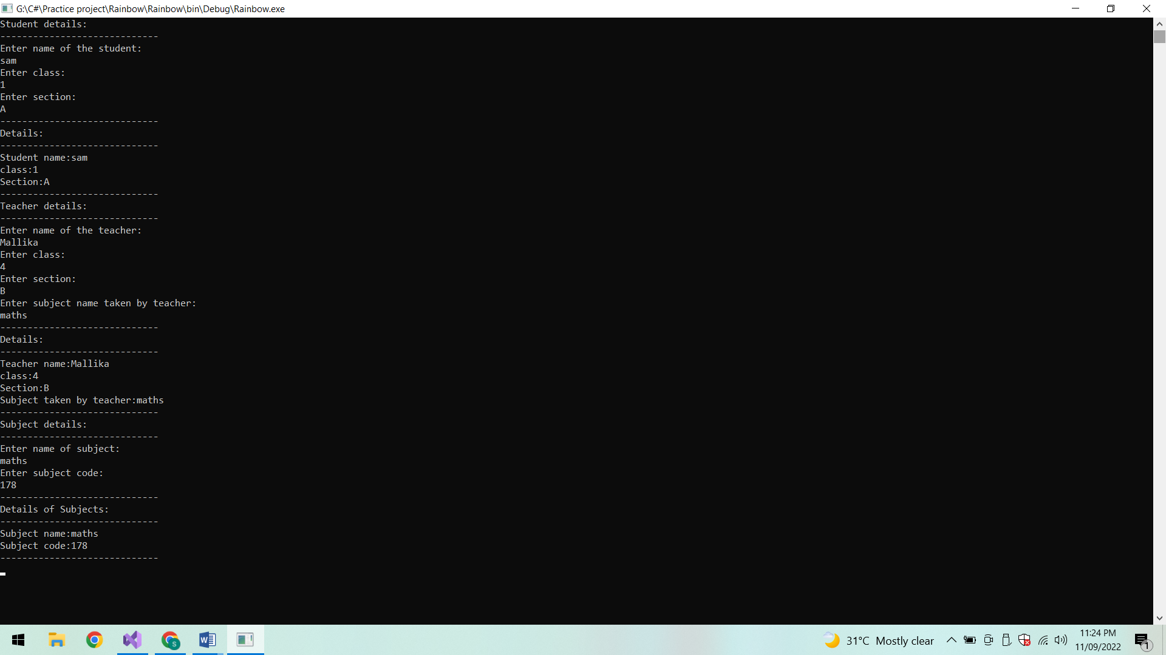

Conclusion:

Thus the OOP based System is created.